1.Create a simple cloud software application and provide it as a service using any
Cloud Service Provider to demonstrate Software as a Service (SaaS).

DATE: 17.11.2025
DAY: Monday

AIM:
To create a simple cloud software application and provide it as a service using
any cloud service provider to demonstrate software as a service (saas).
PROCEDURE:
STEP1: GOTO ZOHO.COM
STEP 2: LOGIN TO THE ZOHO.COM
STEP 3: SELECT ONE APPLICATION
STEP 4: ENTER APPLICATION NAME
STEP 5: CREATED NEW APPLICATION
STEP 6: SELECT ONE FORM
STEP 7: THE SOFTWARE HASE BEEN CREATED.

Implementation:
1.Patient details
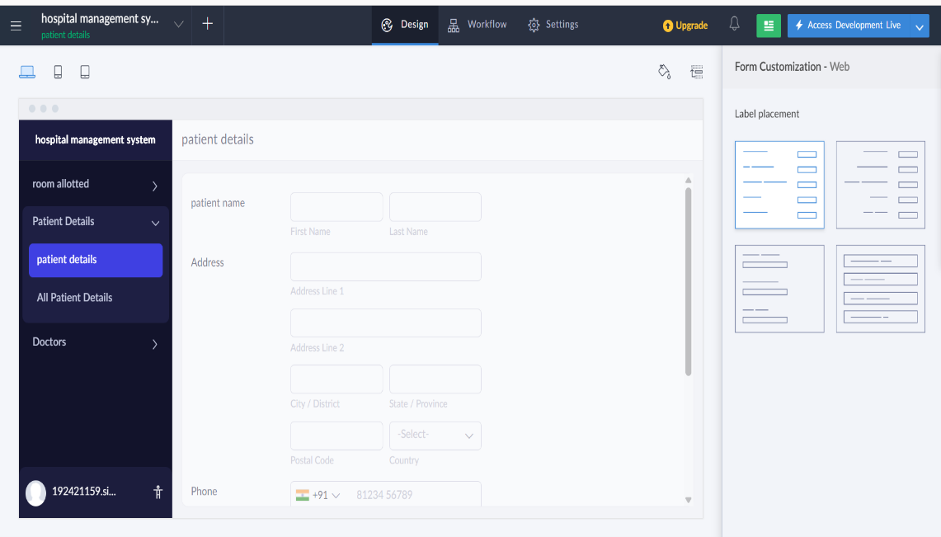
2.Room allotted
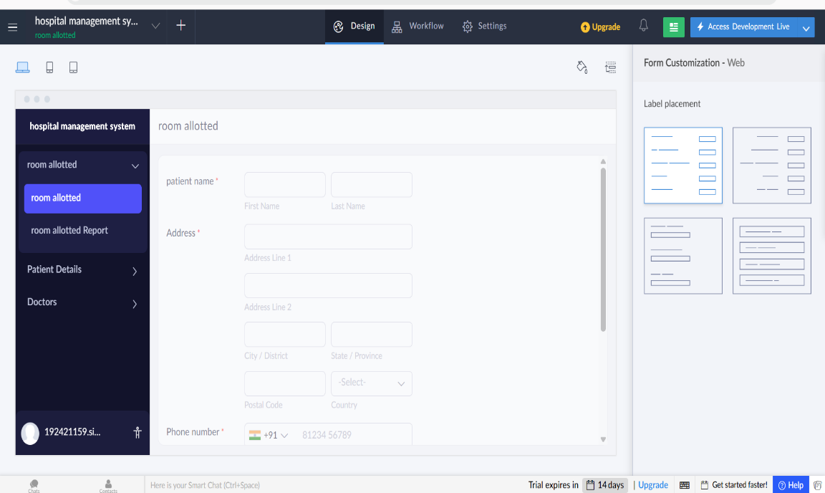

3.Appointed doctor
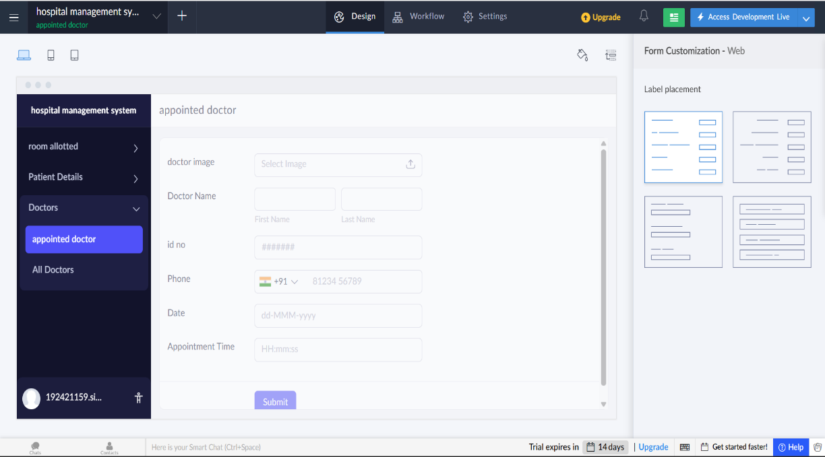
Result:
Successfully Created a simple cloud software application.

